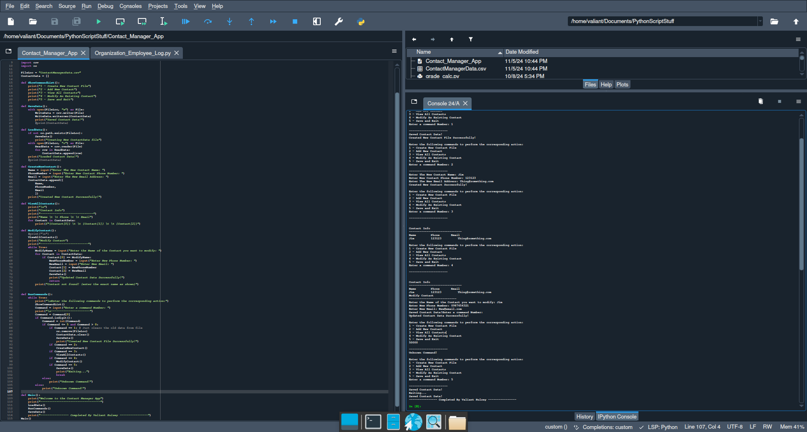#!/usr/bin/env python3

# -*- coding: utf-8 -*-

"""

Created on Tue Nov 5 12:57:08 2024

@author: valiant

"""

import csv

import os

FileLoc = "ContactManagerData.csv"

ContactData = []

def ShowCommandList():

print("1 - Create New Contact File")

print("2 - Add New Contact")

print("3 - View All Contacts")

print("4 - Modify An Existing Contact")

print("5 - Save and Exit")

def SaveData():

with open(FileLoc, "w") as File:

WriteData = csv.writer(File)

WriteData.writerows(ContactData)

print("Saved Contact Data!")

#print(ContactData)

def LoadData():

if not os.path.exists(FileLoc):

SaveData()

print("Creating New ContactData file")

with open(FileLoc, "r") as File:

ReadData = csv.reader(File)

for row in ReadData:

ContactData.append(row)

print("Loaded Contact Data!")

#print(ContactData)

def CreateNewContact():

Name = input("Enter The New Contact Name: ")

PhoneNumber = input("Enter New Contact Phone Number: ")

Email = input("Enter The New Email Address: ")

ContactData.append([

Name,

PhoneNumber,

Email

])

print("Created New Contact Successfully!")

def ViewAllContacts():

print("\n")

print("Contact Info")

print("------------------------------")

print("Name \t \t Phone \t \t Email")

for Contact in ContactData:

print(f"{Contact[0]} \t \t {Contact[1]} \t \t {Contact[2]}")

def ModifyContact():

#print("\n")

ViewAllContacts()

print("Modify Contact")

print("---------------------------")

while True:

ModifyName = input("Enter the Name of the Contact you want to modify: ")

for Contact in ContactData:

if Contact[0] == ModifyName:

NewPhoneNumber = input("Enter New Phone Number: ")

NewEmail = input("Enter New Email: ")

Contact[1] = NewPhoneNumber

Contact[2] = NewEmail

SaveData()

print("Updated Contact Data Successfully!")

return

print("Contact not found! (enter the exact name as shown)")

def RunCommands():

while True:

print("\nEnter the following commands to perform the corresponding action:")

ShowCommandList()

Command = input("Enter a command Number: ")

print("\n----------------------")

Command = Command[0]

if Command.isdigit():

Command = int(Command)

if Command <= 5 and Command > 0:

if Command == 1: # Just clears the old data from file

os.remove(FileLoc)

ContactData.clear()

SaveData()

print("Created New Contact File Successfully!")

if Command == 2:

CreateNewContact()

if Command == 3:

ViewAllContacts()

if Command == 4:

ModifyContact()

if Command == 5:

SaveData()

print("Exiting...")

break

else:

print("Unknown Command!")

else:

print("Unknown Command!")

def Main():

print("Welcome to the Contact Manager App")

print("----------------------------------")

LoadData()

RunCommands()

SaveData()

print("---------------- Completed By Valiant Hulsey ----------------")

Main()